Experiment No – 03

Title - Write a program to find factorial of a number.

Theory-
In programming, a loop is used to repeat a block of code until the specified condition is met. A for loop is a repetition control structure that allows you to efficiently write a loop that needs to execute a specific number of times.
The syntax of a for loop in C programming language is −
for ( init; condition; increment )
{
statement(s);
}
However, all three expressions in the for statement are optional. Even the body is optional.
Working of 'for' loop −
- The init step is executed first, and only once. This step allows you to declare and initialize any loop control variables. You are not required to put a statement here, as long as a semicolon appears.
- Next, the condition is evaluated. If it is true, the body of the loop is executed. If it is false, the body of the loop does not execute and the flow of control jumps to the next statement just after the 'for' loop.
- After the body of the 'for' loop executes, the flow of control jumps back up to the increment statement. This statement allows you to update any loop control variables. This statement can be left blank, as long as a semicolon appears after the condition.
- The condition is now evaluated again. If it is true, the loop executes and the process repeats itself (body of loop, then increment step, and then again condition). After the condition becomes false, the 'for' loop terminates.

Flowchart of for loop
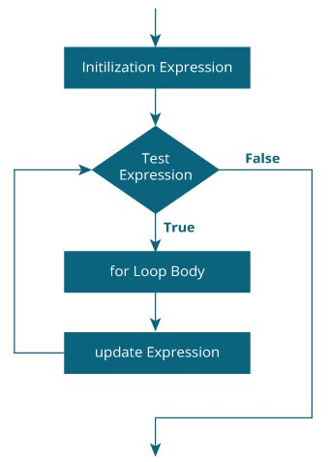

The Comma Operator in ‘for’ Loops-
The Comma Operator (,) is primarily used in conjunction with the ‘for’ statement. This operator permits two different expressions to appear within the ‘for’ Loop Syntax.
Syntax:
for(expr1, expr2; expr3; expr4, expr5)
{
statement(s);
}

Exercise-
- Write a program to list numbers from 1 to 500 which are divisible by 7 and 9.
- Write a program in C to read 10 numbers from keyboard and find their sum and average.
- Write a program in C to display the sum of the series [ 9 + 99 + 999 + 9999 ...].
- Write a program to list first 10 items of Fibonacci series.
- Write a program to test whether the given number is prime.

